A000-ME-Eye-idol-Lexical-rc 3

Case No.: 3

Sumerian compound verbs usually involve a noun immediately before the verb, forming a lexical or idiomatic unit

igi...du8, lit. "eye-open" = "see"

Van der Toorn, Karel. 1997. Worshipping Stones: On the Deification of Cult Symbols, *Journal of Northwest* *Semitic Languages* (23: 1):1-14.

### The Sumerians in southern Mesopotamia developed a logophonetic language in the mid fourth millennium BCE in which the sign of the word signified its meaning and its sound. Sumerian is a language isolate unrelated to any other language including Semitic. During the third millennium BCE the Akkadians in northern Mesopotamia developed the earliest Semitic language. In their contacts with the Sumerians in the south they adopted the use of cuneiform while engaging in intimate linguistic and cultural contacts. Consequently, the Sumerian and Akkadian concepts of deity became closely allied. For instance, the Sumerian concept of deity or powers of a deity developed from the rosette to the cuneiform "DINGIR." In Akkadian this concept of deity became , ***’****il* and ***’****ilu,* which is cognate withthe Northwest Semitic ***’ēl* and Arabic *’Ilāh*.** [According to modern convention, small **capitals identify a Sumerian cuneiform sign, while the Akkadian phonemic value of a sign in a given context is given in lower case** italics. For purposes of clarification in this text all Akkadian words will also be underlined to distinguish their phonemic values from those of other languages.] In Sumerian, "DINGIR" could have the force of an unspoken determinant to specify the meaning of the following word. Thus, Sumerian is conventionally transliterated as a superscript "D" as in DInanna. Akkadian is transliterated acrophonically in which the components of the word stand for its sound as in the Semitic ***’****il* (***’el*) and not for its logographic meaning (Labat and Malbran-Labat 1988: 48-49).**

### In translating these two words for deity (DINGIR and ***’****il*, ***’****ilu*), it is important to clarify that they do not have the meaning of the Judeo-Christian "God" as "**The One object of supreme adoration; the Creator and Ruler of the Universe"** (OED 1989, meaning II). Rather, they are closer to the Indo-European concept of "god" as defined by the Oxford English Dictionary as "An image or other artificial or natural object (as a pillar, a tree, a brute animal) which is worshipped, either as the symbol of an unseen divinity, as supposed to be animated by his indwelling presence, or as itself possessing some kind of divine consciousness and supernatural powers; an idol" (OED 2012, meaning 2). The Indo-European etymology derives "deity" from the Latin *"dea"* ("goddess") and *"deus"* ("god"), which derive from the Sanskrit "*deva*" ("god") and "*devi*" ("goddess").

Now we are in a position to explore the concept of a certain kind of DINGIR and *’il*, *’ilu*, one made of stone. An Old Babylonian juridical text from the Larsa area indicated that "the weapon of the stone deity" witnessed an oath: giš TUKUL *ša dAb-nu-um* (Charpin 1980:243, Nos 58a:23-24). The significant part of this text is that the deity is made of stone and that it witnessed an oath. In other words it was animate. The following deity indicated by its horned headdress and anthropomorphioc visage is also made of stone and probably was an apotropaic deity protecting the entrance to the Tell Brak temple it guarded. Furthermore, the iconography of the rhombic-shaped eyes are very similar to those of the so-called "eye-idols."

In Sumerian the concept of seeing with an open eye suggests a metaphoric sense of prescience since

Sumerian compound verbs usually involve a noun immediately before the verb, forming a lexical or idiomatic unit

igi...du8, lit. "eye-open" = "see"

Furthermore, the eye is important as a device of introspection as well as for physical vision:

ug6, u6[IGI.É]: n., amazement; gaze, glance (['EYE' + 'HOUSE']).

v., to look at; to stare at, gaze; to be impressed.

adj., astonishing. (Hallaoran 2012)

This, when coupled with the Sumerian concept of a seemigly inanimate object like a stone is itself astonishing for it links stone with priest:

šuba(2/3): n., a precious stone - agate (?); a priest (cf., sipad).

which in turn links to the nomadic concept of a watchful shepherd:

sipad, sibad, sipa; šuba; sub2,3: n., shepherd; keeper [SIPA archaic frequency: 4].

v., to pasture, tend (si, 'to keep in order', + bad, 'to let out', or pàd, 'to find').

Therefore we have in a limestone figure the image of a watchful, faithful shepherd as he is embodied in an anthropomorphic bull dating to ca. 2200 BCE.

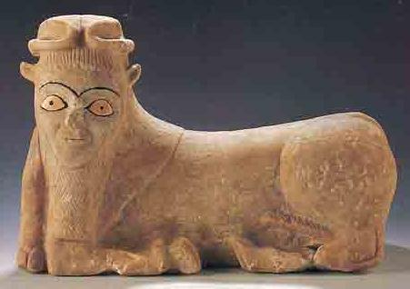

Anthropomorphic apotropaic limestone bull with, ivory eyes and horns of divinity, ca. 2200 BCE 17 in. long, from Tell Brak, from the Syrian Ministry of Culture (after “WorldWide.” *Biblical Archaeology Review*, May/Jun 2000, 72. http://members.bib-arch.org/publication.asp?PubID=BSBA&Volume=26&Issue=3&ArticleID=9 (accessed 3/7/2013)

This association of iconic stone figurines with a priestly and divine function is further suggested by a series of twelve human effigy statues with eye images that are similar to those of the "eye-idols" from Tell Brak were excavated by Henri Frankfort at Tell Asmar in Iraq's Diyala Plain in the 1930's. Tell Asmar was occupied in the Early Dynastic period (3000-2350 BCE) following Tell Brak. If the two sites are related, then the transition from the aniconic Tell Brak "eye-idols" to the Tell Asmar "eye figurines" is provocative for it would indicate that there was a progression from the aniconic to the iconic in the depiction of believers and their deities. Tell Asmar continued to flourish and probably became the provincial capital of Eshnunna during the Ur and Babylonia period (2065-1762 BC). The figurines were stacked in several layers within an 85x50 cm hole 1.25 meters (about 4 feet) below the floor of the structure known as the Square Temple.

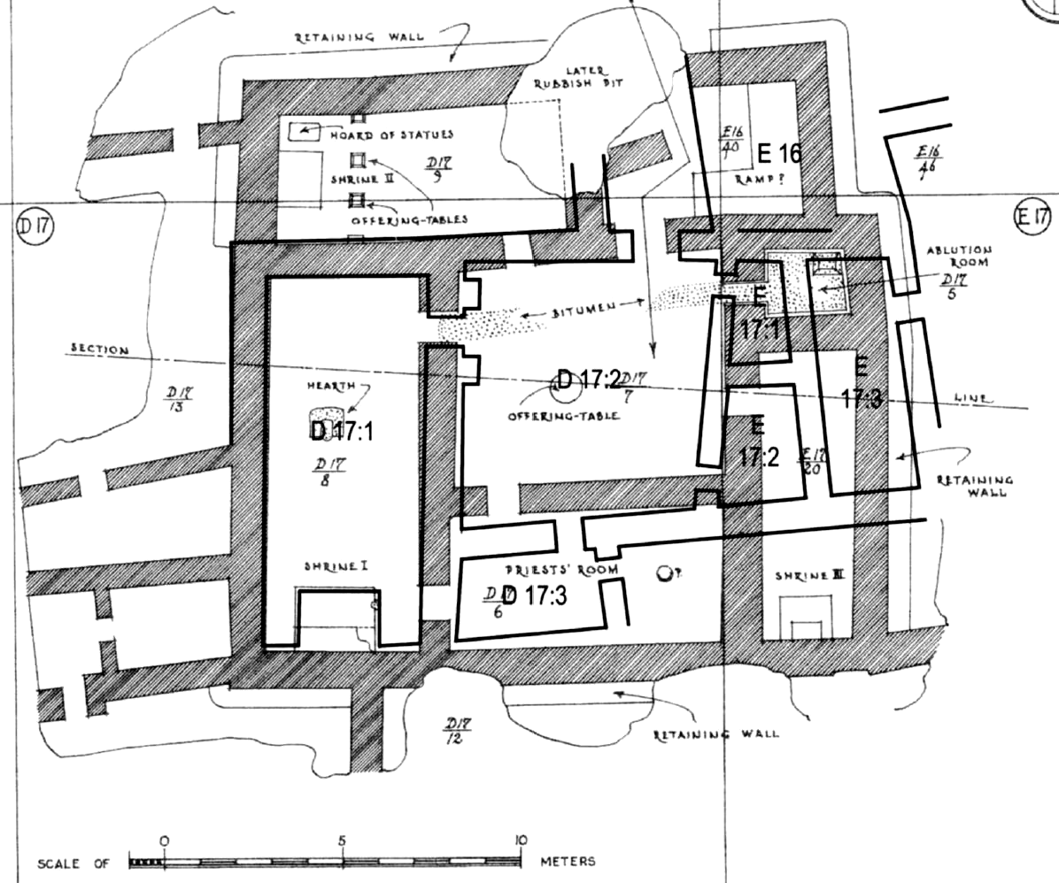

Plan of the Square Temple in diagonal lines with the earlier predecessor in solid lines (adapted from Delougaz and Lloyd 1942, pl. 22).

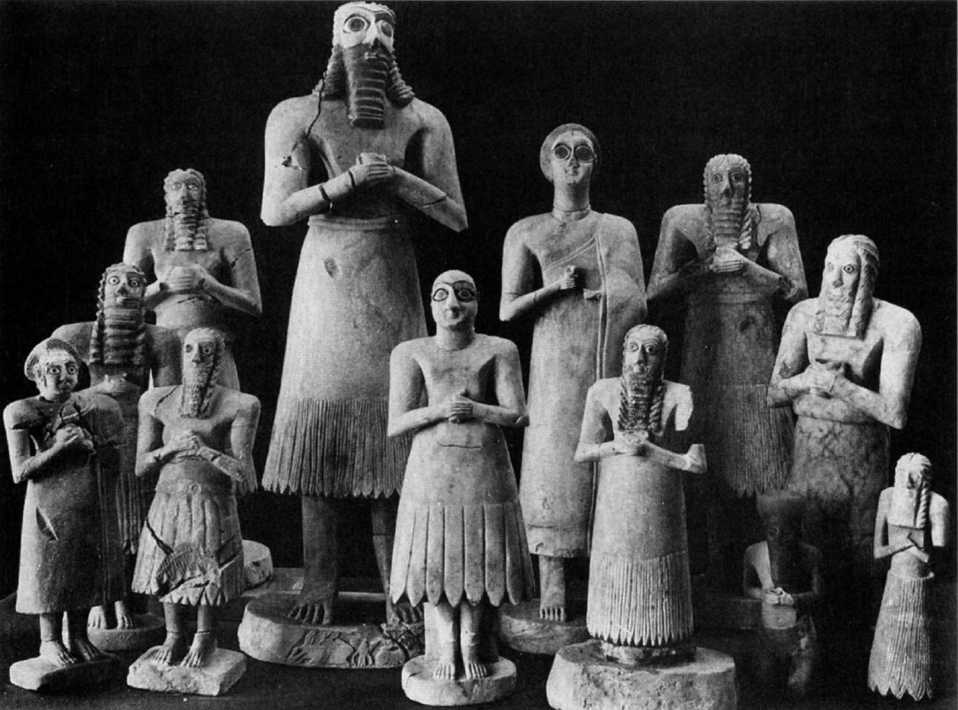

Figurines from Abu Temple at Tell Asmar (after Frankfort 1935, fig. 63).

The statues average about 42 centimeters in height. They are of men and women with large staring eyes, upturned faces, and clasped hands, dressed in the skirts of the [Early Dynastic period of Mesopotamia](http://archaeology.about.com/od/mterms/qt/mesopotamia.htm). They are believed to represent gods and goddesses and their worshipers. The largest male figure is thought to represent the god Abu, based on symbols carved into the base.

The Asmar statues were modeled from processed gypsum (calcium sulphate). The ancient technique involves firing gypsum at about 300 degrees Fahrenheit until it becomes a fine white powder (called plaster of Paris). The powder is then mixed with water and then modeled and/or sculpted.

The exact location of the hoard with regard to the temples is somewhat in question. Most sources refer to it as either below the Abu or Square temples at Asmar. Evans (cited below) believes the hoard, discovered well beneath the floors of the Square Temple, predates both temples.

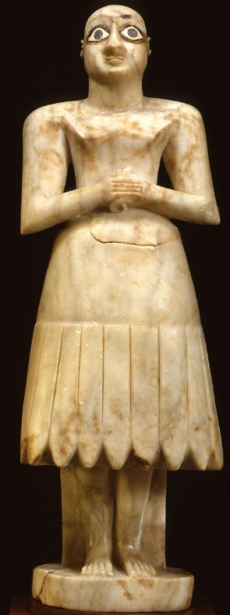

Bald Mesopotamian worshipper figure, Gypsum inlaid with shell and black limestone, 40 cm (1 ft 4 in), 2900-2600 BCE, Abu Temple, Tell Asmar, Iraq. Location: Oriental Institute Museum, Chicago, Illinois, Oriental Institute Museum A12333. From http://teachmiddleeast.lib.uchicago.edu.

This figurine of a bald male worshipper standing reverently before his god was found in the same location as the bearded male divinity below. The significance of being bald indicates a sense of austerity, while long hair and beard indicates its holiness. Statuettes were placed as votive objects in temples to stand in perpetual prayer in place of their owners.

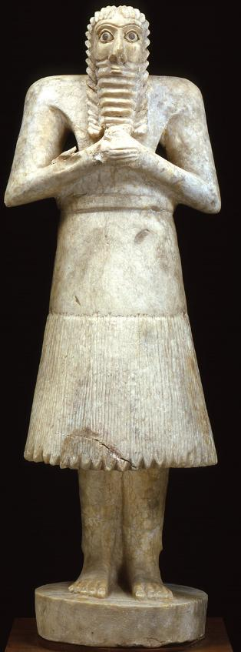

Bearded Mesopotamian deity figure, gypsum inlaid with shell and black limestone, 55 cm (1 ft 9.6 in), 2900-2600 BCE, Tell Asmar, Khafajah, Iraq, Oriental Institute Museum, Chicago, Illinois, Oriental Institute Museum A12331. From http://teachmiddleeast.lib.uchicago.edu.

SHAPE \* MERGEFORMAT 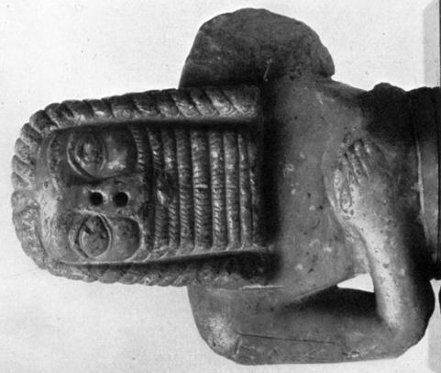

Bearded male figure, reddish calcite, 5 3/4 in high, from the environs of Babylonia before October 1868 (after Gadd 1934, plate XI,1).

This bearded male figure may be another deity. It was found in the environs of Babylonia when it was featured in an article in the *Revue archéologique* of October 1868 (Gadd 1934: 42).

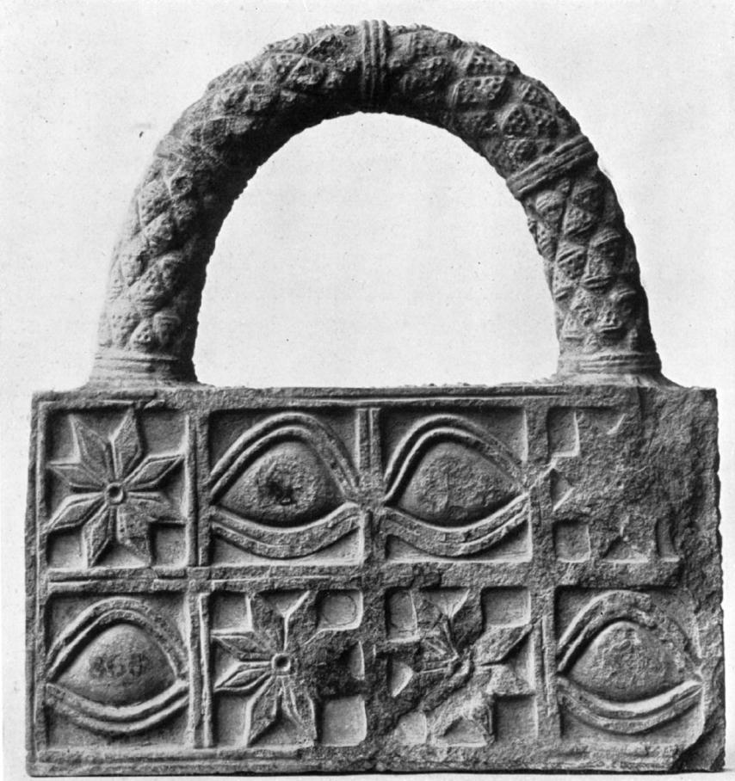

Model of a votive basket (?) of grey slate or schist , 7 5/8 in wide, 8 1/8in. high, from Ur excavations by J. E. Taylor, 1853-1854, object no. 91700 (after Gadd 1934, Plate 12, 1).

This sculpture which appears to be a model of a votive basket would be in keeping with the practice of providing food and libations to deities in their shrines. This figure is carved with the iconographies of both the eye-idol and the eight-pointed rosette  which symbolizes  **DINGIR,** a deity, an emblem of Ishtar or Inana.

Charpin Dominique. 1980. Archives familiales et propriété prinvéé en Babylonie anciennne" *Études de documents de "Tell Sifr."* Geneva: Droz.

Delougaz, P. and Lloyd, Seton. 1942. *Pre-Sargonid temples in the Diyala region*. Chicago: Oriental Institute Publications, 58.

Dimand, Maurice S.. 1945. A Sumerian Sculpture of the Third Millennium B.C., The Metropolitan Museum of Art Bulletin, New Series, (3: 10) : 253-256

Evans, Jean M. 2007 The Square Temple at Tell Asmar and the Construction of Early Dynastic Mesopotamia, ca. 2900-2350 B.C.E. *American Journal of Archaeology* 111(4):599-632.

Frankfort, Henri. 1935. Sumerian sculpture, Burlington Magazine (66: 384): 110-121.

Gadd, C. J. 1934. Babylonian stone carvings of the early period, *The British Museum Quarterly* (9:2): 42-45.

Gibson, McGuire 1982 A Re-Evaluation of the Akkad Period in the Diyala Region on the Basis of Recent Excavations at Nippur and in the Hamrin. *American Journal of Archaeology* 86(4):531-538.

Halloran, John A. 2012. Sumerian Lexicon. Version 3.0. http://www.sumerian.org/sumerlex.htm

Labat, René and Malbran-Labat, Florence. 1988. *Manuel d'Épigraphie Akkadienne, signes , syllabaire, idéogrammes.* Sixième édition augnentéed'addenda. Paris: Libraire Orientaliste Paul Guethner.

OED. 1989.

OED. 2012.

Van der Toorn, Karel. 1997. Worshipping Stones: On the Deification of Cult Symbols, *Journal of Northwest* *Semitic Languages* (23: 1):1-14.